**CSE3017 PROJECT – IR CONTROLLER**

1. The Requirements

In order to decode infrared signals from our remote control, we need to able to solve incoming encoded signals according to the format/protocol the remote control uses.

Our remote control uses a protocol called: NEC according to this website: [https://gist.github.com/steakknife/e419241095f1272ee60f5174f7759867#file-gistfile1-md](https://gist.github.com/steakknife/e419241095f1272ee60f5174f7759867" \l "file-gistfile1-md)

So we implemented a verilog module according to NEC protocol specifications.

1. How NEC Works

NEC protocol uses a modulation called: Pulse Position Modulation. Whenever a key is pressed on remote, the IR sensor receives a dataframe consists of:

* a 9ms leading pulse burst with a 4.5ms space marking the start of dataframe,
* 8-bit address for the receiving device (LSB first),
* 8-bit logical inverse of the address (LSB first),
* 8-bit command (LSB first),
* 8-bit logical inverse of the command (LSB first),
* finally a 562.5µs pulse to signify the end of the dataframe.

For example a dataframe containing: an address of 0x00 (0b00000000) and a command of 0xAD (0b10101101)

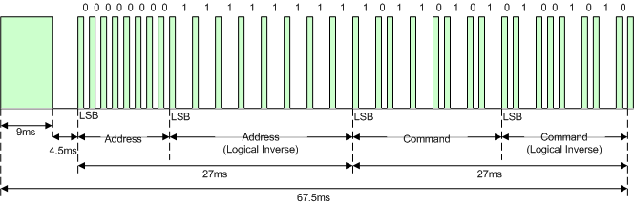

This signal is received. Recognize that all the pulses signifying bits are fixed as 562.5µs pulses only the spaces in between are changing. So this means that we have to somehow count the distances when we are decoding the Pulse Position Modulated signal and decide upon the blank space times. Here is actually 2 types of spaces depending on transmitted bit:

‘0’ Bit:

* a 562.5µs pulse burst followed by a 562.5µs space, with a total transmit time of 1.125ms

‘1’ Bit:

* a 562.5µs pulse burst followed by a 1.6875ms space, with a total transmit time of 2.25ms

And if the key on the remote is continuously being pressed, a repeat code is received:

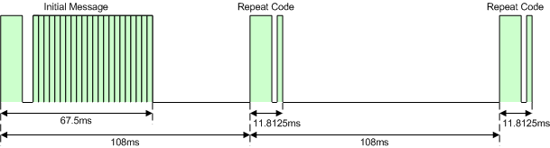

This repeat code consists of:

* a 9ms leading pulse burst
* a 2.25ms space
* a 562.5µs pulse burst to mark the end of the transmitted repeat code

This repeat code is continuously sent at 108ms intervals as long as the key is being pressed.

1. Design

We have used a state machine approach to decode this signals:



At state 00:

* Controller is at IDLE mode, waiting for start mark of the dataframe or received the start mark and getting ready to decode the actual message.

At state 01:

* Controller is at READ mode, decoding each bit by counting the pulses in between the positive edges of the sensor pin. And whenever a bit is decoded it is appended at the MSB of the output register. But last bit is an exception as the last end mark is not received when a repeating code is sent. So go to next state to decode the last bit end decide whether the signal is repeating or ended.

At state 10:

* Controller is at CHECK END mode, decoding the last bit is done here. If the message is ended which means the end pulse mark is received either 562.5µs later (0 bit) or 1.6875ms (1 bit) later then the last bit is decoded and data is valid&ready for a read from outside the controller, go to state IDLE. Otherwise we have to wait for the repeat mark and 40.5ms will be added for the extra wait in between the end of the message and the repeat mark. This means last bit is 0 bit if (40.5 + 0.5625)ms is passed or 1 bit if (40.5 + 1.6875)ms is passed, decide which bit is received and move to last state 11.

At State 11:

* Controller is at REPEAT mode, in this state our job is easier as we only have to just wait and check if the received signal matches with repeat mark or not. This can be done by waiting 108ms if a repeat mark is received and going back to IDLE if marks don’t match.

Also to make this state machine work with the serial data received from the IR sensor we have to sample it in a shift register so at each sample pulse we sample the IR sensor and apply our state machine to it.

We chose a sampling clock of 0.1125ms period which gives us 5 1’s whenever a 0.5625ms pulse is received which is good enough for us. This is done by a simple counter and frequency division. Counter counts up to 5625 and toggles at 2812 giving us a 50MHz (global clock) / 5625 = 8.889 Khz clock.

Of course there is some bugs with this design as the pulse position modulation is not decoded properly and there is differences with our remote sending a different type of repeat mark and such. Still we can get a different code for each button which was our goal from the start.

And finally we created a simple verilog module called “IRTester” to check if the controller actually works as we cannot test it via simulation. Tester shows the last data received from the controller and updated whenever data is valid, in other words decoded. One button is assigned to decide whether MSB 16 bits or LSB 16 bits are shown on digital tube as hexadecimals. Hexadecimal encoding for 7 segments are used here and one hexdigit is shown at each pulse of 1Khz clock. If button is not pressed LSB 16 bits are shown as hex on digital tube. Otherwise MSB 16 bit are shown.

1. Code:

**Infrared Controller Module:**

module IRController(

input clk,

input res,

input ir,

output reg [31:0] code,

output reg dataValid

);

// The state machine registers for decoding NEC IR Protocol:

reg [1:0] state;

// Shift register to stream binary IR signals over:

reg [23:0] IRBitStream;

// Registers for demodulating Pulse Distance Modulation:

reg bitDecoded;

reg [4:0] nBitDecoded;

reg bit;

reg [8:0] pdCount;

// Registers for generating carrier clock by frequency division:

reg sampleCLK;

reg [12:0] counter;

// Counter register for setting countdowns to match timing:

reg [9:0] pulseCount;

initial begin

code <= 32'h00000000;

dataValid <= 1'b0;

state <= 2'h0;

IRBitStream <= 24'h000000;

code <= 32'h00000000;

bitDecoded <= 1'b0;

nBitDecoded <= 5'd0;

bit <= 1'b0;

pdCount <= 9'd0;

counter <= 13'd0;

sampleCLK <= 1'b0;

pulseCount <= 10'd0;

end

// Lets create a slower clock to get around 5 samples each pulse (0.5625 ms / 5 = 0.1125 ms)

always @(posedge clk)

begin

if(res)

begin

counter <= 13'd0;

sampleCLK <= 1'b0;

end

// 0.1125 ms period / 8.889KHz clock

if(counter == 13'd5625)

begin

counter <= 13'd0;

sampleCLK <= 1'b0;

end

else

begin

if(counter == 13'd2812)

begin

sampleCLK <= 1'b1;

end

counter <= counter + 13'd1;

end

end

always @(posedge sampleCLK)

begin

if(res)

begin

code <= 32'h00000000;

dataValid <= 1'b0;

state <= 2'h0;

IRBitStream <= 24'h000000;

bitDecoded <= 1'b0;

nBitDecoded <= 5'd0;

bit <= 1'b0;

pdCount <= 9'd0;

pulseCount <= 10'd0;

end

// Sample IR data into shift register to create a bitstream:

IRBitStream <= {IRBitStream[22:0], ir};

if(pulseCount == 10'd0) // If no wait is required

// State Machine for reading NEC protocol IR signal:

case(state)

2'h0: begin // IDLE | START

// If start signal is matched. Start reading data transmitted.

if(IRBitStream == {16'b1111111111111111, 8'b00000000})

begin

dataValid <= 1'b0;

code <= 32'h00000000;

pulseCount <= 10'd1; // Wait for 1 clock.

state <= 2'h1; // Go to READ state

end

end

2'h1: begin // READ

// If a bit is decoded add it to the shift register and if all decoded than give data to output.

if(bitDecoded)

begin

code <= {bit, code[31:1]}; // Sample IR data into shift register to create a bitstream

bitDecoded <= 1'b0; // Set flag back to zero.

if(nBitDecoded == 5'd31)

begin

// If all the message is demodulated (except last) and streamed using shift register go to next state:

nBitDecoded <= 5'd0;

pulseCount <= 10'd1; // Wait for 1 clock.

state <= 2'h2; // Go to CHECK END state

end

end

else

begin

// Count pulse distances if we are trying to demodulate pulse distance.

pdCount <= pdCount + 9'd1;

// If next pulse is here calculate the distance and decode the bit:

if(~IRBitStream[1] & IRBitStream[0])

begin

// If the distance count is 15 clocks (1.678 ms) next bit is a 1 bit or less (0.5625 ms) which means 0 bit is the next bit.

bit <= pdCount < 9'd14 ? 1'b0 : 1'b1;

pdCount <= 9'd0;

bitDecoded <= 1'b1;

nBitDecoded <= nBitDecoded + 5'd1;

end

end

end

2'h2: begin // CHECK END

if(bitDecoded)

begin

if(pdCount > 9'd15)

begin

// No end pulse is recieved instead next mark for REPEAT is recieved:

// Get the difference between next repeat mark and last pulse to get last bit:

// If the pulse distance count between is 40.5 + 1.6875 = 42.1875 ms than last bit is 1

// or less (40.5 + 0.5625 = 41.0625 ms) than last bit is 0

code[31] <= pdCount < 9'd370 ? 1'b0 : 1'b1;

pulseCount <= 10'd460; // Wait 460 clocks (51.75 ms) to reach next repeat mark.

state <= 2'h3; // Go to REPEAT

end

else

begin

// If next pulse is here calculate the distance and decode the last bit and END:

// If the distance count is 15 clocks (1.678 ms) last bit is a 1 bit or less (0.5625 ms) which means 0 bit is the last bit.

code[31] <= pdCount < 9'd14 ? 1'b0 : 1'b1;

pulseCount <= 10'd24; // Back to IDLE and wait for 24 clocks (70.65 ms) so we have enough time to load new samples for next state.

state <= 2'h0; // Go back to IDLE

end

bitDecoded <= 1'b0;

dataValid <= 1'b1;

pdCount <= 9'd0;

end

else

begin

if(~IRBitStream[1] & IRBitStream[0])

begin

// Last bit decoded:

bitDecoded <= 1'b1;

end

else

begin

// Count pulse distances if we are trying to demodulate pulse distance.

pdCount <= pdCount + 9'd1;

end

end

end

2'h3: begin // REPEAT

if(IRBitStream == {3'b000, 16'b1111111111111111, 4'b0000, 1'b1})

begin

// Continue repeating

pulseCount <= 10'd960; // Wait for 960 clocks (108 ms).

end

else

begin

// END repeating

pulseCount <= 10'd24; // Back to IDLE and wait for 24 clocks (70.65 ms) so we have enough time to load new samples for next state.

state <= 2'h0; // Back to IDLE

end

end

endcase

else

begin

// Countdown if wait is required

pulseCount <= pulseCount - 13'd1;

end

end

endmodule

**Infrared Tester Module:**

module IRTester(

input clk,

input res,

input ir,

input btnSel,

output [7:0] seg,

output reg [3:0] dig

);

wire [31:0] code;

wire dataValid;

IRController(

clk,

~res,

ir,

code,

dataValid

);

reg clock1KHz;

reg [15:0] pulseCount;

reg [2:0] counter;

reg [15:0] hexSel;

reg [31:0] hex8;

reg [6:0] hexEncoding;

initial begin

clock1KHz <= 1'b0;

pulseCount <= 16'd0;

dig <= 4'b0111;

counter <= 3'b000;

hexSel <= 16'h0000;

hex8 <= 32'h00000000;

end

always @(posedge dataValid or negedge res)

begin

hex8 <= code;

end

always @(posedge clk)

begin

if(~res)

begin

clock1KHz <= 1'b0;

pulseCount <= 16'd0;

end

// 50000 clock cycles are needed to count for 1KHz clock (50000 division):

if(pulseCount == 16'd50000)

begin

pulseCount <= 16'd0;

clock1KHz <= 1'b0;

end

else

begin

if(pulseCount == 16'd25000)

begin

clock1KHz <= 1'b1;

end

pulseCount <= pulseCount + 16'd1;

end

end

always @(posedge clock1KHz)

begin

if(~res)

begin

dig <= 4'b0111;

counter <= 3'b000;

hexSel <= 16'h0000;

end

if(counter == 3'b100)

begin

dig <= 4'b0111;

hexSel <= ~btnSel ? hex8[31:16] : hex8[15:0];

counter <= 3'b000;

end

else

begin

dig <= {dig[2:0], dig[3]};

// Set digital tube to show recieved code:

case (hexSel[3:0])

4'b0000 : hexEncoding <= 7'h3f;

4'b0001 : hexEncoding <= 7'h06;

4'b0010 : hexEncoding <= 7'h5b;

4'b0011 : hexEncoding <= 7'h4f;

4'b0100 : hexEncoding <= 7'h66;

4'b0101 : hexEncoding <= 7'h6d;

4'b0110 : hexEncoding <= 7'h7d;

4'b0111 : hexEncoding <= 7'h07;

4'b1000 : hexEncoding <= 7'h7f;

4'b1001 : hexEncoding <= 7'h6f;

4'b1010 : hexEncoding <= 7'h77;

4'b1011 : hexEncoding <= 7'h7c;

4'b1100 : hexEncoding <= 7'h39;

4'b1101 : hexEncoding <= 7'h5e;

4'b1110 : hexEncoding <= 7'h79;

4'b1111 : hexEncoding <= 7'h71;

endcase

hexSel <= {4'b0000, hexSel[15:4]};

counter <= counter + 3'b001;

end

end

assign seg[7] = ir;

assign seg[6] = ~hexEncoding[6];

assign seg[5] = ~hexEncoding[5];

assign seg[4] = ~hexEncoding[4];

assign seg[3] = ~hexEncoding[3];

assign seg[2] = ~hexEncoding[2];

assign seg[1] = ~hexEncoding[1];

assign seg[0] = ~hexEncoding[0];

endmodule

1. Practical Testing:

The remote control:

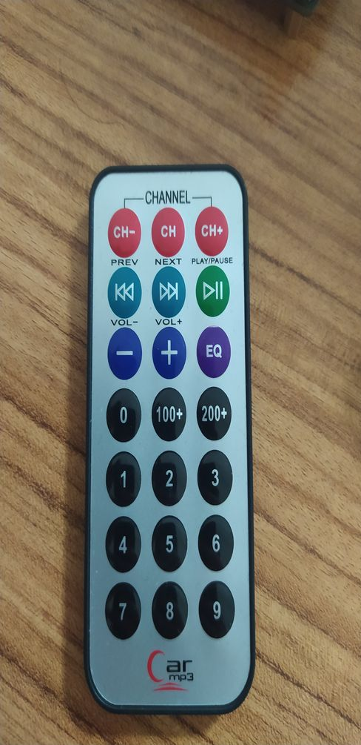

Pressing the “CH-” key LSB 16 bit appears as:

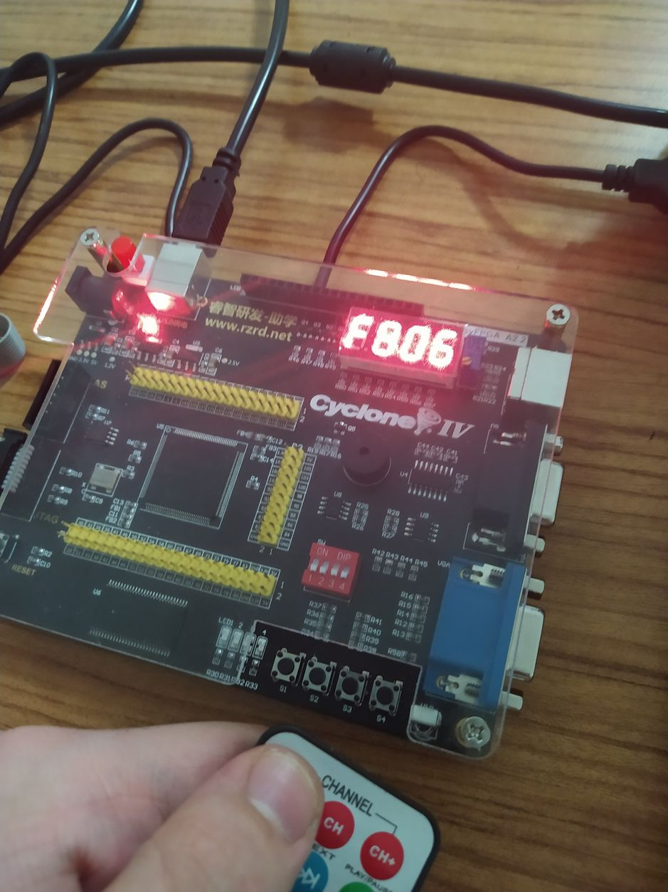

Pressing the “CH-” key MSB 16 bit appears as:

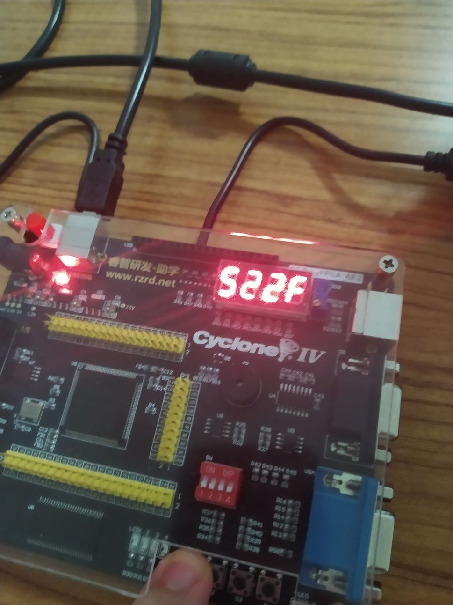

Pressing the “2” key MSB 16 bit appears as:

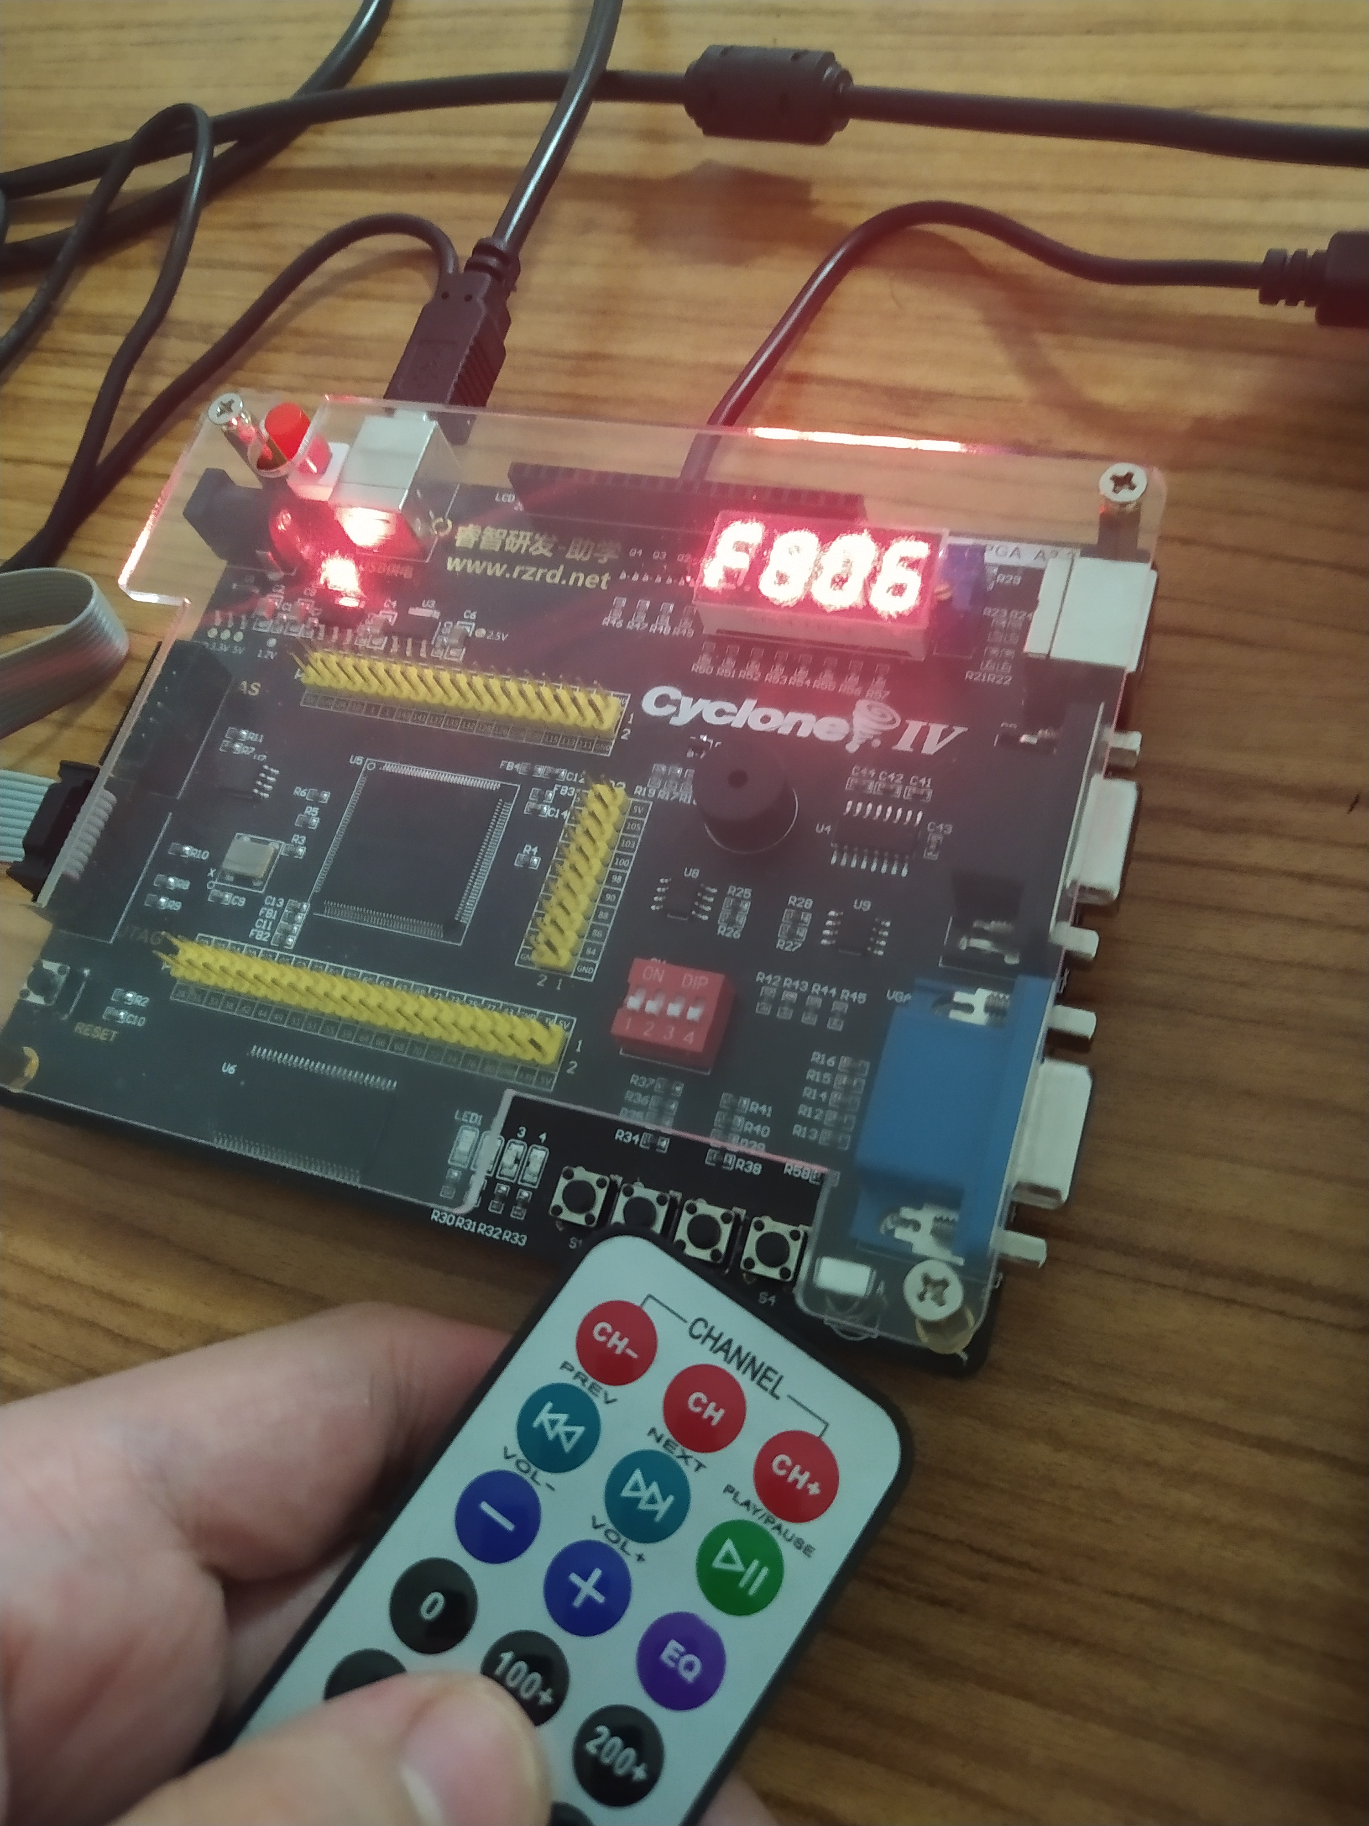

Pressing the “2” key LSB 16 bit appears as:

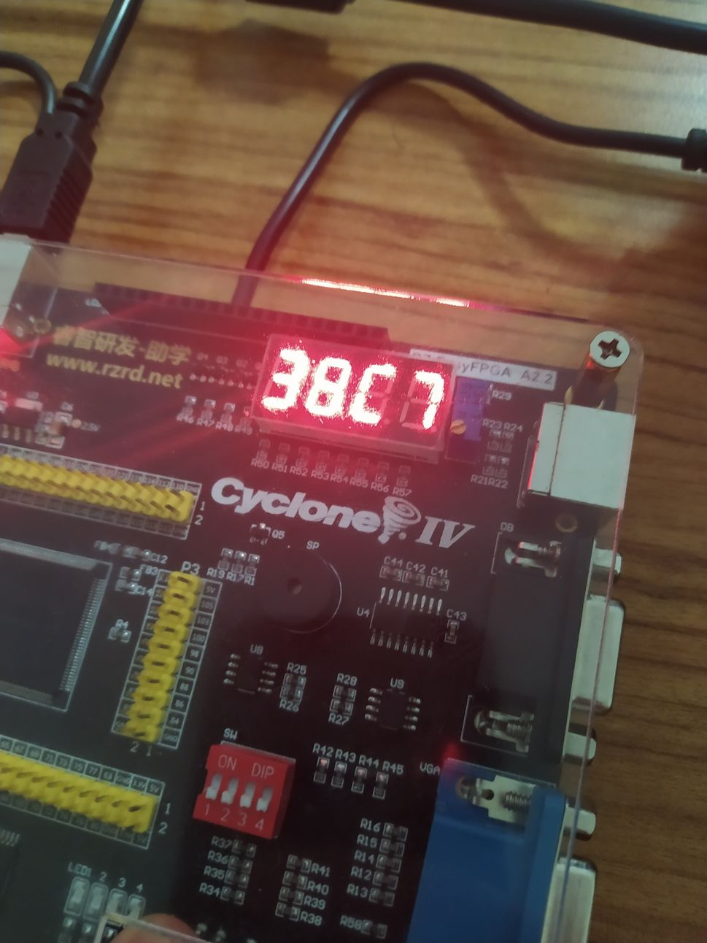

Pressing the “6” key MSB 16 bit appears as:

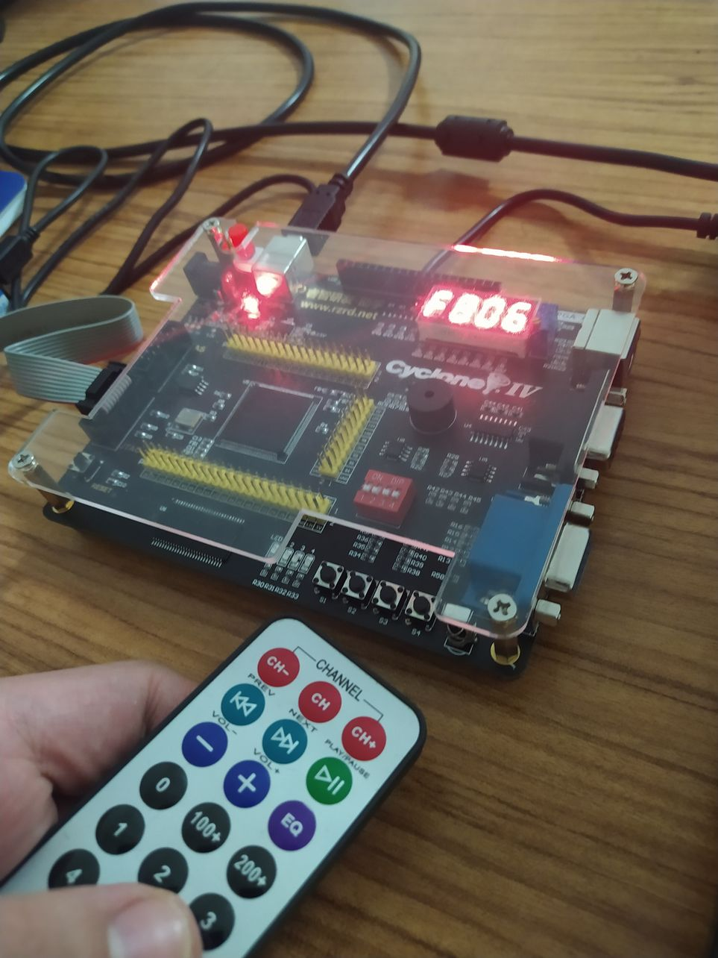

Pressing the “6” key LSB 16 bit appears as:

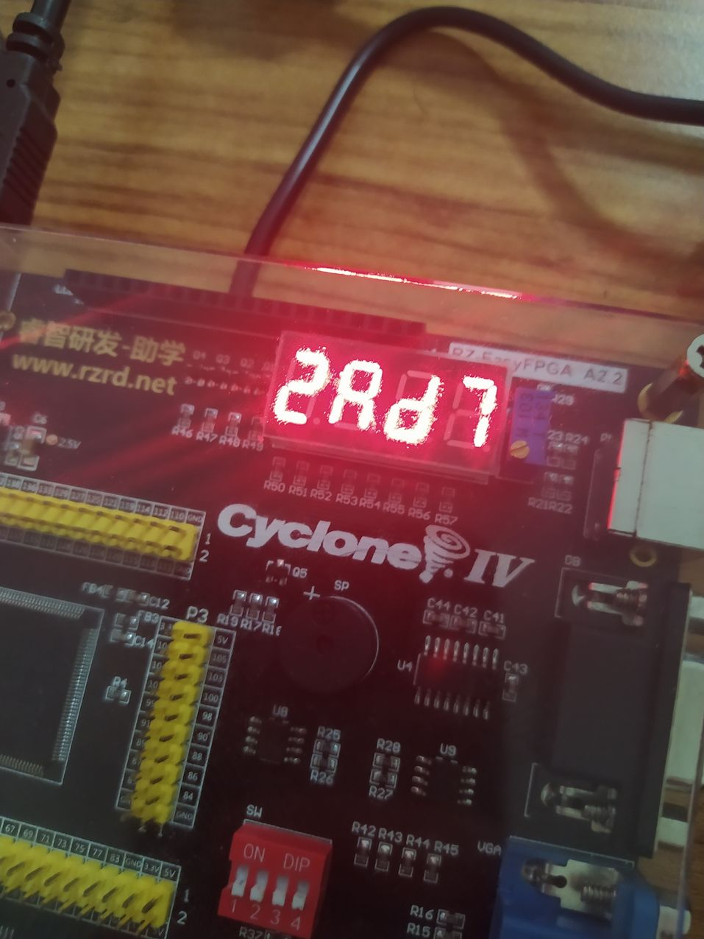

And here is the demo video link showcasing that pressing same keys work as expected:

<https://drive.google.com/file/d/1kRWvI_2ibFG1_LLcNJ_n0ShbtbhvnC6f/view?usp=sharing>